|  |  |  |  |  |  |  |  |
| --- | --- | --- | --- | --- | --- | --- | --- |
| **Project Identification** | | | | | | | |
| **Project Name** | | | | | | | |
| S/4 Hana | | | | | | | |
| **Organization** | | | | | | | |
| Toyo Tires | | | | | | | |
| **Project Manager** | | | | **Work Stream** | | | |
| Ketan Rathor | | | | Order to Cash | | | |
| **Document Identification** | | | | | | |
| **Document Name**  *<right click file name to update, this instruction will not print>* | | | | | **Document Location (repository/path/name)**  *<right click file path to update, this instruction will not print>* | |
| **OTC.R.172 Requirement for Annual Volume Bonus** | | | | | TBD | |
| **Version** | | **Status** | | | **Date (YYYY-MM-DD)**  *<right click date to update, instruction will not print>* | **Document Classification** |
| 1.0 | | Initial | | | 2022-26-09 | Shared |
|  | | | | | | |
| **Functional Author** | | Mriganka K Mondal | | | | |
| **Technical Author** | |  | | | | |
| **Revision History** | | | | | | | |
| **Revision Date** | **Revised By** | | **Comments** | | | | |
|  |  | |  | | | | |
|  |  | |  | | | | |
|  |  | |  | | | | |
| **Approval History** | | | | | | | |
| **Date** | **Name** | | **Comments** | | | | |
|  |  | |  | | | | |
|  |  | |  | | | | |
|  |  | |  | | | | |

Contents

1 General Information 3

1.1 Overview 3

1.2 Business Requirements 3

1.3 Assumptions 3

1.4 Integration Points and Dependencies 3

1.5 Security and Control Considerations 3

1.6 Other Relevant Information 3

2 Functional Unit Test Scenarios 4

3 Reports <Delete section if not relevant> 5

3.1 Selections Screen or Filter Values 5

3.2 Report Layout (Sort/Sequencing Criteria) 5

3.3 Pre-Processing (Before Selection Screen) 5

3.4 Special Program Logic 5

3.5 Detailed Technical Design 5

3.6 Other Activities 5

3.7 Report Fields 6

3.8 Batch Info 6

# General Information

## Overview

The Volume Bonus Program is paid out quarterly based on what the customer has achieved. Two volume bonus reports are used for calculation. 99% of the incentives are calculated based on the two reports. One report includes National Accounts Sale to get the percentage. But you pay out on the net. For calculation of the rate, you don’t do that for the National Accounts.

## Business Requirements

The Volume Bonus for Passengers and Light Truck is based on the sales $.

The Business needs a report Year to Date based on Sold to Party. One of percentage and one $$ amount. In the $ report the National Accounts sales are excluded.

In the percentage report the Gross sales minus Discounts, minus warranty claims and other credit notes or sales adjustments are used to get LTPA summary for calculating the percentage.

In the $ report the Gross sales minus Discounts, minus warranty claims and other credit notes or sales adjustments and National Account sales are excluded to get LTPA summary for calculating the percentage.

The Volume Bonus for Truck Bus is based on quantity.

Whichever tier they would be qualifying would be based on the percentage report.

Similarly, in the $ report the Gross sales minus Discounts, minus warranty claims and other credit notes or sales adjustments and National Account sales are excluded to get LTPA summary for calculating the percentage.

## Assumptions

<List any system or business assumptions>

## Integration Points and Dependencies

<List key integration points between this unit of work and other business processes, WRICEF objects, etc. Include both upstream and downstream impacts>

Not Applicable

## Security and Control Considerations

<List data security or sensitivity considerations, a proposed business role for the transaction, and any business process controls that will need to be validated as part of this WRICEF>

Authorization / Security Role to be decided

## Other Relevant Information

# Functional Unit Test Scenarios

| Test Case | Description | Fiori Tile / Navigation | Expected Results |
| --- | --- | --- | --- |
|  |  |  |  |
| To be updated |  | To be updated | To be updated |

# Reports

<Identify the type of report to be used. I.e.: ALV >

## Selections Screen or Filter Values

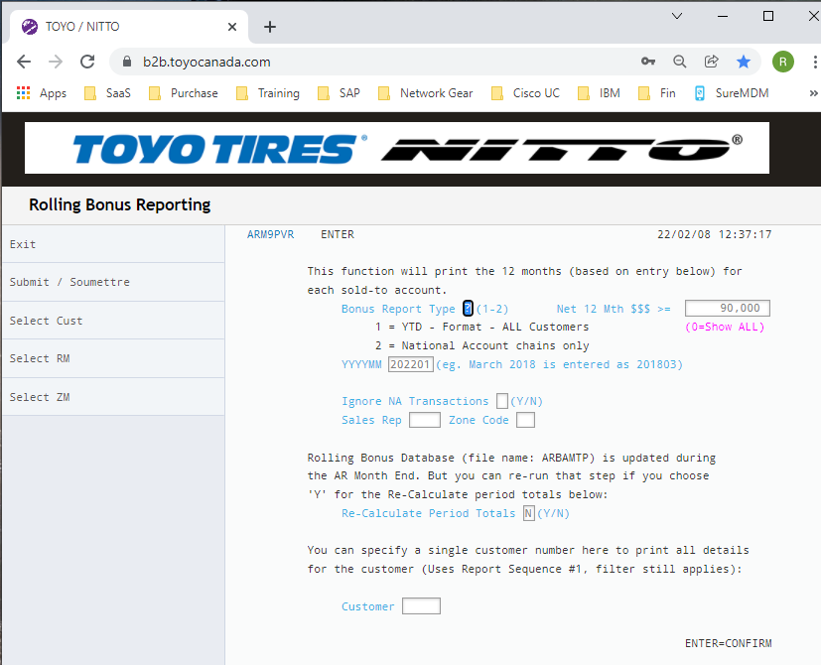

| Field Name | Description | Default Values | Comments |
| --- | --- | --- | --- |
| Sales Org (M) |  |  |  |
| Dist. Channel (M) |  |  |  |
| YYYYMM (M) |  |  |  |
| Bonus Report Type | 1 or 2 |  | 1. YTD for all customers 2. NA Chains only |
| Ignore NA Accounts | Y/N |  |  |
| Customer |  |  |  |

## Report Layout (Sort/Sequencing Criteria)

<Include a mock-up in excel file or a picture/screenshot of layout>

Excel file attached which has the Report out and Logic and Assumption

[05-2022 VB % Report.xlsx (sharepoint.com)](https://toyotiresus.sharepoint.com/:x:/r/sites/S4HANAGTTCIProjectWithGyanSys/_layouts/15/Doc.aspx?sourcedoc=%7B98E7B8C9-A231-4FDD-B41C-79055088AE56%7D&file=05-2022%20VB%20%25%20Report.xlsx&action=default&mobileredirect=true)

[05-2022 VB $ Report.xlsx (sharepoint.com)](https://toyotiresus.sharepoint.com/:x:/r/sites/S4HANAGTTCIProjectWithGyanSys/_layouts/15/Doc.aspx?sourcedoc=%7B4692BB73-E18B-42F7-9851-5CF7F1262140%7D&file=05-2022%20VB%20%24%20Report.xlsx&action=default&mobileredirect=true)

## Pre-Processing (Before Selection Screen)

<Any screen considerations for the report, pre-populating of drop downs, user or role restrictions, default variants, etc.>

ZANNUAL_BONUS

## Special Program Logic

<Required logic to select data (if not standard selection/join)

Calculation logic

Output presentation logic (totaling, rollups, sorting, etc)>

## Detailed Technical Design

<All objects created for this WRICEF

Specific Code logic that needs to be understood to support

Technical dependencies>

PROGRAM NAME: ZSAL_OCM_ANNUAL_BONUS_REPORT

5/26

Use the creation date to pick up the data for each month. VBRK-ERDAT

**06/12**

Exclude the Billing documents which have been cancelled. VBRK=FKSTO <>X will exclude the billing documents which have been cancelled.

05/26 - Consider Pricing Procedure VBRK-KALSM= ZCASTD

05/26 - **LT + PA Qty** Report for Ignore NA Sales – Only Consider F2- (**CBRE**). Consider only LT & PA

Get the Qty

Let this be A

05/26 - **LT + PA Qty** Report for including NA Sales - Only consider F2 – ZG21 + ZF22 +ZF21 – ZG22 – (**CBRE**)

Get the Qty

Let this as B

05/26 - Do not need the below options

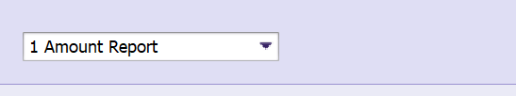

05/26 - Logic in Progress

**Put the documents in VBRP**

**LT + PA Amount – Sum of** VBRP-BRTWR for LT and PA. Same Logic for TB

Base Price which is VBRP-BRTWR (Subtotal 9) ----(1)

I~~f VBRP-MATKL = 1016 = Do not include (COOP)~~

~~G2 Invoices – Exclude VBRP-MATKL = 1016~~

**06/05 - Additional doc types to consider**

**~~Sum of~~** ~~VBRP-BRTWR~~

~~Go to VBRK~~

~~Consider Billing Type VBRK-FKART =L2 & G2 and Pricing procedure VBRK-KALSM= ZCASTD~~

~~Then Put those documents in VBRP-VBELN and VBRP-MVGR3 <>NVB (Not equal to NVB)~~

~~Get the preceding Credit Memo Request / Debit Memo Request No from VBRP- VGBEL~~

~~Now put those documents in VBAK-VBELN and get the doc Type which is VBAK-AUART and check for CR and DR~~

~~Take those documents and put it back in VBFA-VBELN and get the subsequent Billing document.~~

~~Take those billing documents and VBRP-VBELN and get the value of VBRP-BRTWR~~

~~Add this to (1)~~

**~~Alternate Logic~~**

~~Go to Table: WCB_VBRK_VBRP_BV~~

~~Pass Billing type (WCB_VBRK_VBRP_BV) – FKART = L2 & G2, Pricing procedure KALSM = ZCASTD~~

~~Pass (WCB_VBRK_VBRP_BV) – MVGR3 <>NVB (Not equal to NVB)~~

~~Check Reference doc no (WCB_VBRK_VBRP_BV)- VGBEL = Credit Memo Request / Debit Memo Request No~~

~~Take Base Price (WCB_VBRK_VBRP_BV)- BRTWR~~

**Alternate Logic**

**06/12**

Go to Table

ISDBILLDOCITMANA – Put exchange Type = M and CURR = CAD

Pass the BILLINGDOCUMENTTYPE=L2 and G2,

CREATIONDATE= (whatever you are putting to get the other values)

SDPRICINGPROCEDURE=ZCASTD,

ADDITIONALMATERIALGROUP3<>NVB (exclude NVB)

SALESDOCUMENTITEMCATEGORY=G2N and L2N

PRODUCTHIERARCHYNODE=P&L (Second Character)

BILLINGDOCUMENTISCANCELLED<>X (exclude X)

Get the Billing documents --- (2)

Get

ITEMGROSSAMOUNTOFBILLINGDOC

Add this to (1)

Qty Excluding NA Sales – This is where you need to include the Invoice Types G2 and L2

[Credit Memo and Debit Memo.xlsx (sharepoint.com)](https://toyotiresus.sharepoint.com/:x:/r/sites/S4HANAGTTCIProjectWithGyanSys/_layouts/15/Doc.aspx?sourcedoc=%7B2DD147E4-FF71-4481-AB8B-A4BA7549F35A%7D&file=Credit%20Memo%20and%20Debit%20Memo.xlsx&action=default&mobileredirect=true)

LT +PA Discount – (This should be the Billing documents (F2-CBRE + (2))

Gross Value – Base Discount = Base Price

Gross Value – Base Price = Base Discount

VBRP-Kzwi1-VBRP-brtwr= ABap can find out (Base discount)

All Discount – Base Discount = LT+PA Discount (In the report)

VBRP-Kzwi2 - (Base Discount) = ABap can find out

LT+PA Sub Total – LT + PA Amount - LT+PA Discount (This is VBRP-GKWRT)

06/13 - Add the billing documents from (2) to get Lt + PA Discount

LT+ PA Bonus – Volume Bonus given for the particular month

**06/05 BILLING TYPE G2,** Preceding Order Type ZICR with Order Reason Volume Bonus Credit Memo and Material Group – NVB

The sales data at Ship to Party Level is the source of this report. The month-wise sales data is extracted at Sold to Party.

~~The dealer discounts and any other discounts which has the below GLs will be used in this report.~~

~~TB Discounts =~~  ~~42251 ZCNT-42253, 42503, 44106 (ZPAD), 44840-44846, 44848~~

~~LT Discounts =~~  ~~42127 ZCNT, 42502 ZCNT, 44105 ZPAD, 44241 ZEPD, 44243 ZEPD, 44245 ,44700-44722 ZSPC, 44731-44738~~

~~PA Discounts =~~  ~~42126 ZCNT, 42501 ZCNT, 44100 (ZPAD, 44200-44237 ZMAD, ZMAP, 44240, 44242 ZEPD, 44244, 44415, 44723-44724 ZNCG~~

~~LT+PA Discounts = 42121-42125, 42500, 44238-44239, 44515, 44847, 45100 ZSHB, 45150-45190~~

~~For the dealer discounts please consider the below discounts~~

**~~ZCNT, ZPAD, ZEPD, ZMAD, ZMAP, ZSHB~~**

**02/15 ZCNT, ZPAD, ZEPD, ZEPA, KA03, KA04, ZNSH**

The warranty claims and other credits are backout. G2 Invoices will be considered.

The National Account Sales are included in LT=PA / TB Summary while calculating the percentage

Material Group to be considered for identifying LT, PA & TB.

The National Account Sales are excluded in LT&PA / TB Summary while calculating the $ report

This report will be divided into 2 halves. On the left will be Passenger and Light Truck and, on the Right, will be Truck Bus. (Passenger and Light Truck and Truck Bus will be identified by Product Hierarchy 2 in the Material Master.)

**If It is P & L in level 2 of the PH it is LT & PA**

**If it is T in Level 2 it is Truck Bus**

02/15 - Consider Pricing Procedure VBRK-KALSM= ZCASTD

02/15 - Report for excluding NA Sales – Only Consider F2- (**CBRE**)

02/15 - Report for including NA Sales - Only consider F2 – ZG21 + ZF22 +ZF21 – ZG22 – (**CBRE**)

ZG21 – NA Dealer Credit Memo

ZF21 – NA Chain Debit Memo

ZG22 – NA Chain Credit Memo

ZF22 – NA Dealer Debit Memo

OK Tire – NA Claims + some Returns

-ZG21 + ZF22

Always F2 > ZG21 > ZF22

Example F2 100 ZG21 10 ZF22 2

(Not given you anything related to S1)

Use the Billing Types F2 for pulling the report for including NA sales

In the selection criteria if it is Ignore NA sales = Y, then exclude the NA Sales

|  |  |  |
| --- | --- | --- |
| LT+PA NA Sales | VBRP-NETWR for NA Accounts exclude Billing Type ~~ZF21 &ZF22 & ZG21 & ZG22 along with F2~~ | Include this column when selection is Ignore NA sales = Y |

Report should show 12 rows (one month per row) and then sub-totals for sold-to customer.

All Invoices – ~~F2, G2, ZF21 &ZF22 & ZG21 & ZG22~~

For a particular month consider all sales for a particular customer for these invoices to get LT+PA Quantity

Selection: Ignore NA Customers

Only consider Invoices F2, **G2 (CBRE)**

Different Title Bars used for 4 different reports based on input combinations:

1. Amount with NA
2. Amount Without NA
3. Quantity with NA
4. Quantity without NA

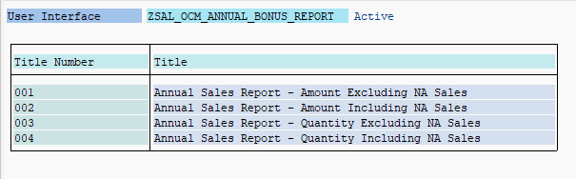

## Other Activities

<Drill downs, automatic printing, etc.>

## Report Fields

| Field Name | Heading | DB ref / Calculate Field | Comments |
| --- | --- | --- | --- |
| Sold to |  |  |  |
| Month |  |  |  |
| LT+PA Qty |  | VBRP-FKIMG of all the invoices | Only Mat Price group LT& PA Tires to be considered |
| LT+PA Amount (a) |  | VBRP-NETWR |  |
| LT+PA Discounts (b) |  | VBRP-NETWR- VBRP-KZWI1 |  |
| LT=PA Subtotal (c) |  | (a) – (b) |  |
| LT+PA Claims (d) |  | VBRP-NETWR for Return G2 |  |
| LT+PA Summary |  | (c) – (d) |  |
| TB Qty |  |  | Do the same thing as above with Mat Price Grp TB |
| TB Amount |  |  |  |
| TB Discounts |  |  |  |
| TB Subtotal |  |  |  |
| TB Claims |  |  |  |
| TB Summary |  |  |  |

## Batch Info

<Frequency, dependencies, recipients, etc.>

Test Data

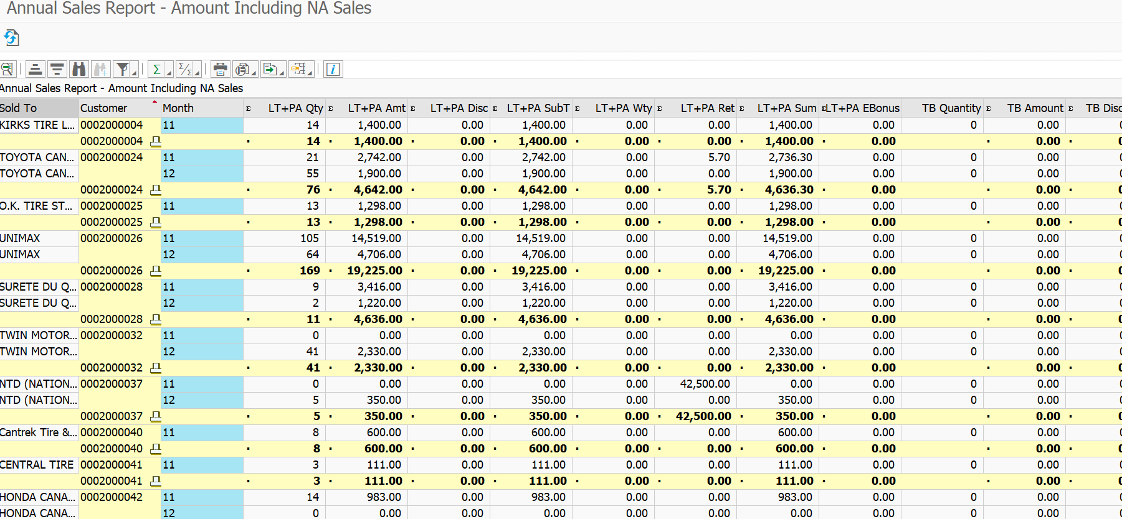

New Logic 06/13

Including NA Sales.

Use only VBRK and VBRP

Customer

Month

LT+PA Qty

LT+ PA Amount

LT+PA Discount

LT+PA Sub Total

LT+PA Returns

|  |  |  |  |
| --- | --- | --- | --- |
| Field Name | Heading | DB ref / Calculate Field | Comments |
| Sold to |  |  |  |
| Month |  |  |  |
| LT+PA Qty |  | VBRP-FKIMG of all the invoices  For VBRP=PRODH = P & L (second character of PH) | Only Mat Price group LT& PA Tires to be considered |
| LT+PA Amount (a) |  | VBRP-BRTWR |  |
| LT+PA Discounts (b) |  | VBRP-KZWI2- [ {VBRP-KZWI1 – VBRP-BRTWR (Subtotal 9)} | All discount – Base discount |
| LT+PA Subtotal (c) |  | (a) – (b) | LT + PA Amount - LT+PA Discount |
| LT+PA Returns (d) |  | VBRK-FKART(CBRE) |  |
| LT+PA Summary |  | (c) – (d) |  |
| TB Qty |  |  | Do the same thing as above with Mat Price Grp TB |
| TB Amount |  |  |  |
| TB Discounts |  |  |  |
| TB Subtotal |  |  |  |
| TB Claims |  |  |  |
| TB Summary |  |  |  |

**NEW LOGIC**

Excluding NA Sales.

Selection Criteria

Use the creation date to pick up the data for each month. VBRK-ERDAT

**06/12**

**Excluding National Account Sales –**

Exclude the Billing documents which have been cancelled. VBRK=FKSTO <>X will exclude the billing documents which have been cancelled.

Use the creation date to pick up the data for each month. VBRK-ERDAT

|  |  |  |  |  |
| --- | --- | --- | --- | --- |
|  | Field Name | Heading | DB ref / Calculate Field | Comments |
| SL | Sold to |  |  |  |
| 1 | Month |  | VBRK-ERDAT | Put dates here |
| 2 | LT+PA Qty |  | **Use Billing Doc Tyes F2, CBRE**  VBRK-FKART= F2, CBRE  VBRK-ERDAT=Put Dates  VBRK-KUNAG(Sold-to-Party)  Exclude the Billing documents which have been cancelled. VBRK=FKSTO <>X  VBRK-KALSM= ZCASTD  F2 - CBRE  GET THOSE BILLING DOCS = A  Put the Billing documents in VBRP and get  VBRP-FKIMG of all the invoices  For VBRP=PRODH = P & L (second character of PH) | Only Mat Price group LT& PA Tires to be considered  Use P & L combined  Use T for Truck Bus |
| 3 | LT+PA Amount (a) |  | Go to Table  ISDBILLDOCITMANA – Put exchange Type = M and CURR = CAD  Pass the BILLINGDOCUMENTTYPE=L2 and G2,  CREATIONDATE= (same as SL 1),  Sold- to Party = SOLDTOPARTY,  SDPRICINGPROCEDURE=ZCASTD,  ADDITIONALMATERIALGROUP3<>NVB (exclude NVB)  SALESDOCUMENTITEMCATEGORY=G2N and L2N  PRODUCTHIERARCHYNODE=P&L (Second Character)  BILLINGDOCUMENTISCANCELLED<>X (exclude X)  Get the Billing documents --- (B)  Put A + B = C In VBRP=VBELN  Get the values of  VBRP-BRTWR (Subtotal 9)  Consider F2, L2 Values as positive  CBRE , G2 VALUES as Negetive |  |
| 4 | LT+PA Discounts (b) |  | Put C in VBRP and get  Gross Value – Base Discount = Base Price  Gross Value – Base Price = Base Discount  VBRP-KZWI1-VBRP-BRTWR= D (Base discount)  All Discount – Base Discount = LT+PA Discount (In the report)  VBRP-KZWI2 – D (Base Discount) = LT +PA Discount  Consider F2, L2 Values as Negetive  CBRE , G2 VALUES as positive |  |
| G | LT+PA Subtotal (c) |  | 1. - (b) |  |
| H | LT+PA WTY |  | **TBD (Logic mentioned at bottom of the document)** |  |
|  | LT+PA Returns (d) |  | **Use Billing Doc Type CBRE**  VBRK-FKART=CBRE  VBRK-ERDAT=Put Dates  VBRK-KUNAG(Sold-to-Party)  Exclude the Billing documents which have been cancelled. VBRK=FKSTO <>X  VBRK-KALSM= ZCASTD  GET THOSE BILLING DOCS = A  Put the Billing documents in VBRP- VBELN and get  VBRP-FKIMG of all the invoices  For VBRP=PRODH = P & L (second character of PH) |  |
| G-H | LT+PA Sum |  | G - H |  |
|  | LT+PA E-Bonus |  | Go to Table  ISDBILLDOCITMANA – Put exchange Type = M and CURR = CAD  Pass the BILLINGDOCUMENTTYPE= G2,  CREATIONDATE= (same as SL 1),  Sold- to Party = SOLDTOPARTY,  SDPRICINGPROCEDURE=ZCASTD,  ADDITIONALMATERIALGROUP3<>NVB (exclude NVB)  SALESDOCUMENTITEMCATEGORY=G2W  PRODUCTHIERARCHYNODE=P&L (Second Character)  BILLINGDOCUMENTISCANCELLED<>X (exclude X)  Get the value of BILLINGDOCUMENTTYPE= CUSTOMERCREDITMEMONETAMOUNT, (Net Value) |  |
|  | x |  |  |  |
|  | x |  |  |  |
|  |  |  |  |  |
|  |  |  |  |  |

**INCLUDING National Account Sales –**

Exclude the Billing documents which have been cancelled. VBRK=FKSTO <>X will exclude the billing documents which have been cancelled.

Use the creation date to pick up the data for each month. VBRK-ERDAT

|  |  |  |  |  |
| --- | --- | --- | --- | --- |
|  | Field Name | Heading | DB ref / Calculate Field | Comments |
| SL | Sold to |  |  |  |
| 1 | Month |  | VBRK-ERDAT | Put dates here |
| 2 | LT+PA Qty |  | **Use Billing Doc Tyes F2, CBRE, ZF21, ZF22, ZG21 ZG22**  VBRK-FKART= F2, CBRE, ZF21, ZF22, ZG21, ZG22  VBRK-ERDAT=Put Dates  VBRK-KUNAG(Sold-to-Party)  Exclude the Billing documents which have been cancelled. VBRK=FKSTO <>X  VBRK-KALSM= ZCASTD  GET THOSE BILLING DOCS = A  Put the Billing documents in VBRP and get  VBRP-FKIMG of all the invoices  For VBRP=PRODH = P & L (second character of PH)  F2 – CBRE + ZF21 + ZF22 – ZG21- ZG22 | Only Mat Price group LT& PA Tires to be considered  Use P & L combined  Use T for Truck Bus |
| 3 | LT+PA Amount (a) |  | Go to Table  ISDBILLDOCITMANA – Put exchange Type = M and CURR = CAD  Pass the BILLINGDOCUMENTTYPE=L2 and G2,  CREATIONDATE= (same as SL 1),  Sold- to Party = SOLDTOPARTY,  SDPRICINGPROCEDURE=ZCASTD,  ADDITIONALMATERIALGROUP3<>NVB (exclude NVB)  SALESDOCUMENTITEMCATEGORY=G2N and L2N  PRODUCTHIERARCHYNODE=P&L (Second Character)  BILLINGDOCUMENTISCANCELLED<>X (exclude X)  Get the Billing documents --- (B)  Put A + B = C In VBRP=VBELN  Get the values of  VBRP-BRTWR (Subtotal 9)  F2 – CBRE + L2 – G2 + ZF21 + ZF22 – ZG21- ZG22 |  |
| 4 | LT+PA Discounts (b) |  | Put C in VBRP and get  Gross Value – Base Discount = Base Price  Gross Value – Base Price = Base Discount  VBRP-KZWI1-VBRP-BRTWR= D (Base discount)  All Discount – Base Discount = LT+PA Discount (In the report)  VBRP-KZWI2 – D (Base Discount) = LT +PA Discount  - F2 + CBRE - L2 + G2 - ZF21 - ZF22 + ZG21 + ZG22 |  |
| G | LT+PA Subtotal (c) |  | (a) - (b) |  |
| H | LT+PA WTY |  | **TBD (Logic mentioned at bottom of the document)** |  |
|  | LT+PA Returns (d) |  | **Use Billing Doc Type CBRE**  VBRK-FKART=CBRE  VBRK-ERDAT=Put Dates  VBRK-KUNAG(Sold-to-Party)  Exclude the Billing documents which have been cancelled. VBRK=FKSTO <>X  VBRK-KALSM= ZCASTD  GET THOSE BILLING DOCS = A  Put the Billing documents in VBRP and get  VBRP-FKIMG of all the invoices  For VBRP=PRODH = P & L (second character of PH) |  |
| G-H | LT+PA Sum |  | G-H |  |
|  | LT+PA E-Bonus |  | Go to Table  ISDBILLDOCITMANA – Put exchange Type = M and CURR = CAD  Pass the BILLINGDOCUMENTTYPE= G2,  CREATIONDATE= (same as SL 1),  Sold- to Party = SOLDTOPARTY,  SDPRICINGPROCEDURE=ZCASTD,  ADDITIONALMATERIALGROUP3<>NVB (exclude NVB)  SALESDOCUMENTITEMCATEGORY=G2W  PRODUCTHIERARCHYNODE=P&L (Second Character)  BILLINGDOCUMENTISCANCELLED<>X (exclude X)  Get the value of BILLINGDOCUMENTTYPE= CUSTOMERCREDITMEMONETAMOUNT, (Net Value) |  |
|  | x |  |  |  |
|  | x |  |  |  |
|  |  |  |  |  |
|  |  |  |  |  |

**New Warranty Logic: 06/23**

**LT+PA WTY:**

Go to **PVWTYV** table.

Pass PNWTYV- V_PARNR (Partner)

Pass PNWTYV- CREADAT (Created on)

Take PNWTYV-PNGUID (Internal Number)

After getting lists of Internal number from PNWTYV table,

Go to **PVWTY** table,

PASS PVWTY- VERSION_GUID (Internal number)

Check PVWTY-REJCD NE "REJ" and PVWTY-REJCD NE "blank"

Take PVWTY- MATNR (Material number)

Take PVWTY – VALOC (OC Approved) claim $ granted! Put this as a Negetive Value

Then Go to **MARA** table.

PASS MARA- MATNR (Material)

Check MARA- PRDHA {P & L (second character of PH)}

After checking P & L (Second character of PH)

Go to **PVWTY** table,

PASS PVWTY- VERSION_GUID (Internal number)

PASS PVWTY- MATNR (Material number)

Check PVWTY-REJCD NE "REJ" and PVWTY-REJCD NE "blank"

Take PVWTY – VALOC (OC Approved) claim $ granted!